Additional file 2: Japanese version of the final RSO
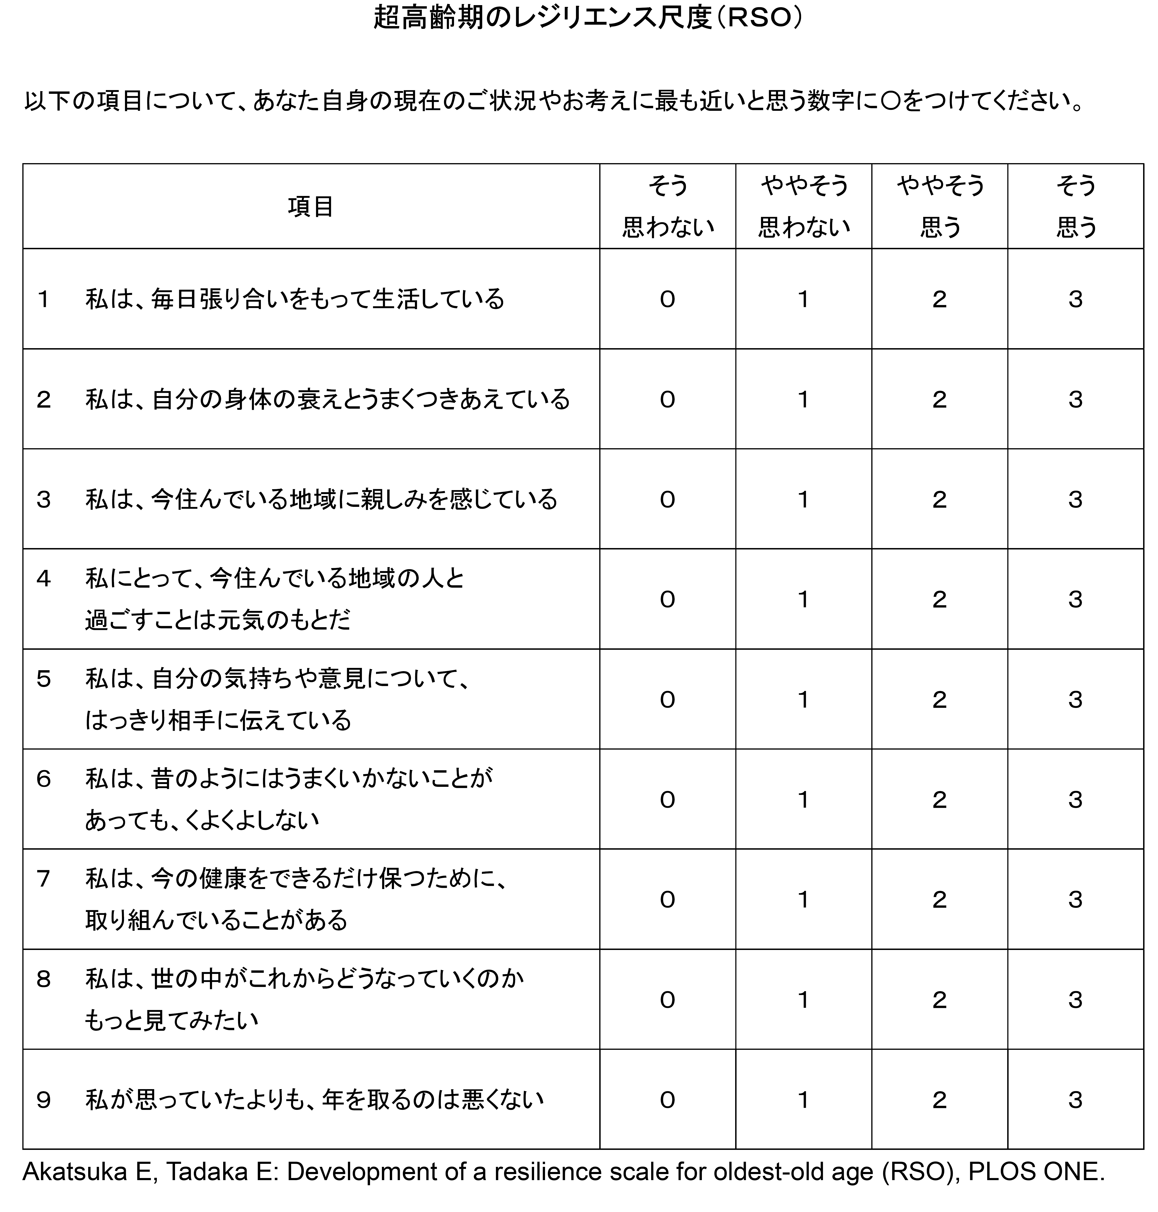
Akatsuka E, Tadaka E: Development of a resilience scale for oldest-old age (RSO), BMC Geriatrics,2021.

